Lab Exercise 5–Provisioning an S3 Bucket on AWS

Exercise Steps:
Step 1: Create a New Directory:
Create a new directory to store your Terraform configuration:
mkdir Terraform-S3-Demo
cd Terraform-S3-Demo
Step 2: Create the Terraform Configuration File (main.tf):
Create a file named main.tf with the following content:
terraform {
required_providers {
aws = {
source = "hashicorp/aws"
version = "5.31.0"
}
}
}

provider "aws" {
region = "us-east-1" # Replace with your preferred region
access_key = "your IAM access key" # Replace with your Access Key
secret_key = "your secret access key" # Replace with your Secret Key
}

This file sets up the Terraform AWS provider.

Step 3: Create a Terraform Configuration File for the S3 Bucket (s3.tf):
Create another file named s3.tf with the following content:
resource "aws_s3_bucket" "my_bucket" {
bucket = "my-demo-s3-bucket"
tags = {
Name = "Terraform-S3-Bucket"
}
}
This file provisions an S3 bucket with a unique name using a random string suffix.

Output:-

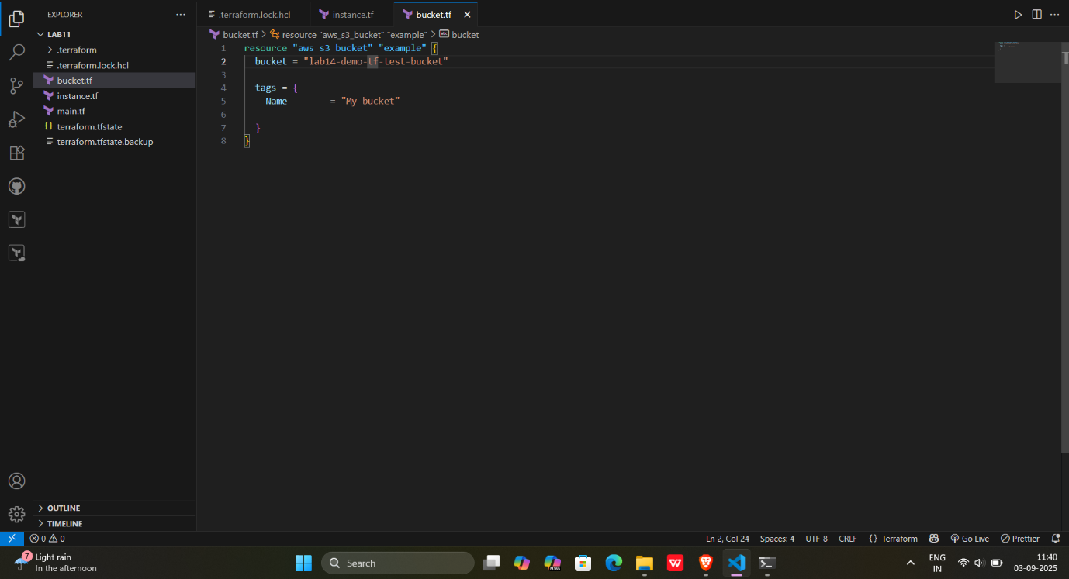

Step 4: Initialize Terraform:
Run the following command to initialize your Terraform working directory:
terraform init

Step 5: Review the Plan:
Preview the changes Terraform will make:
terraform plan
Review the output to ensure it meets your expectations.

Output:-

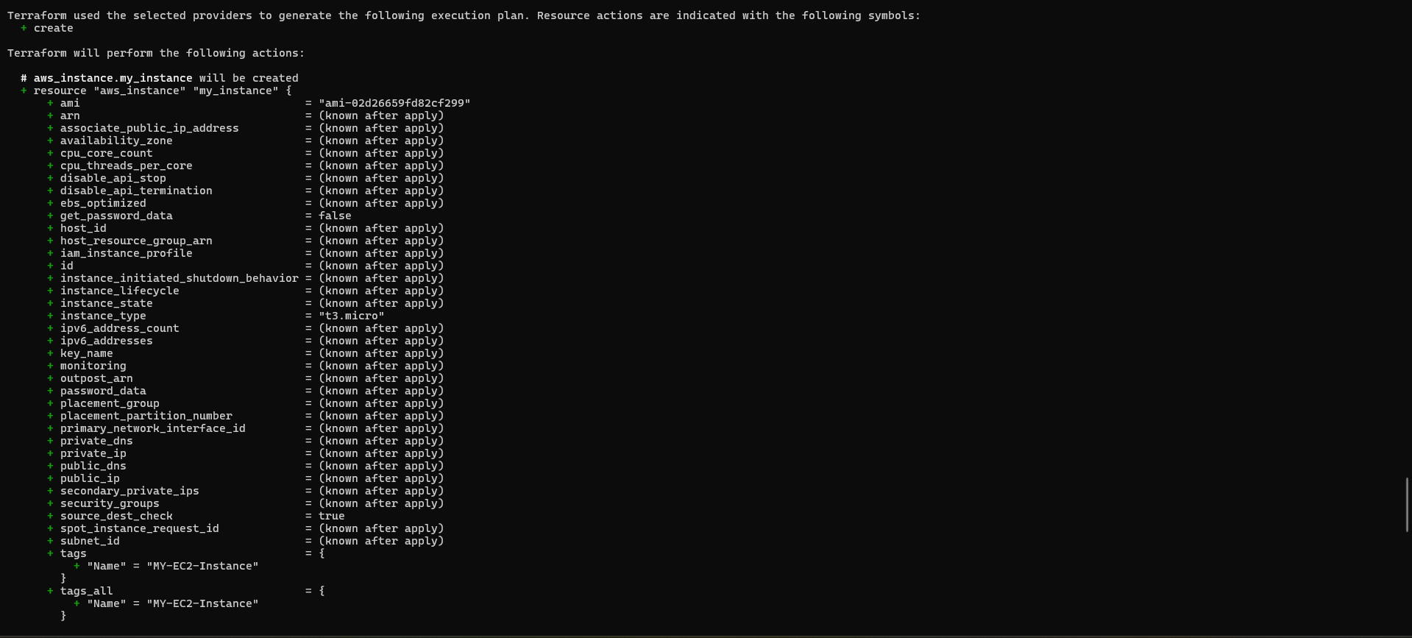
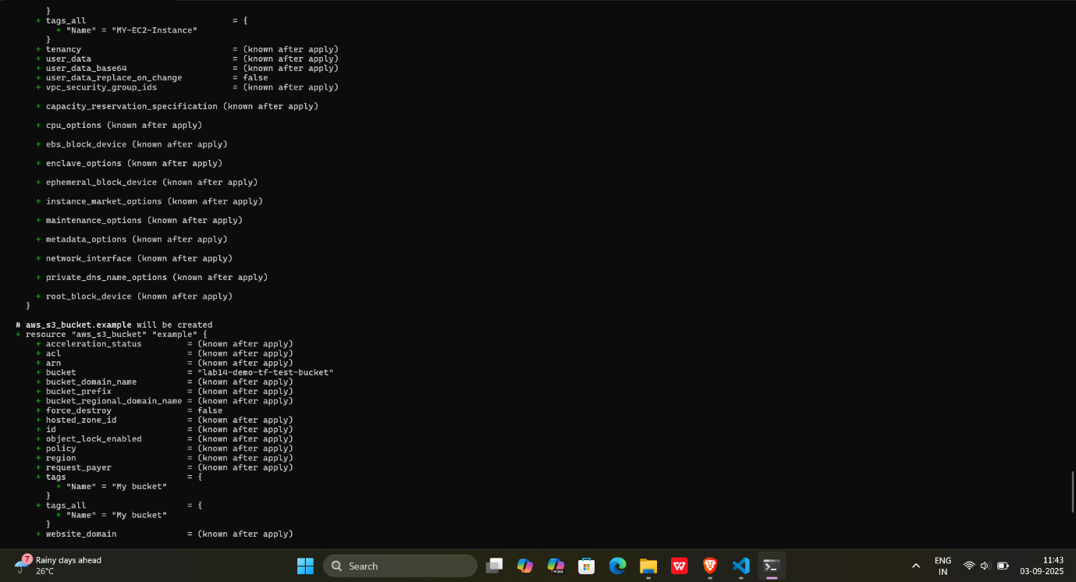
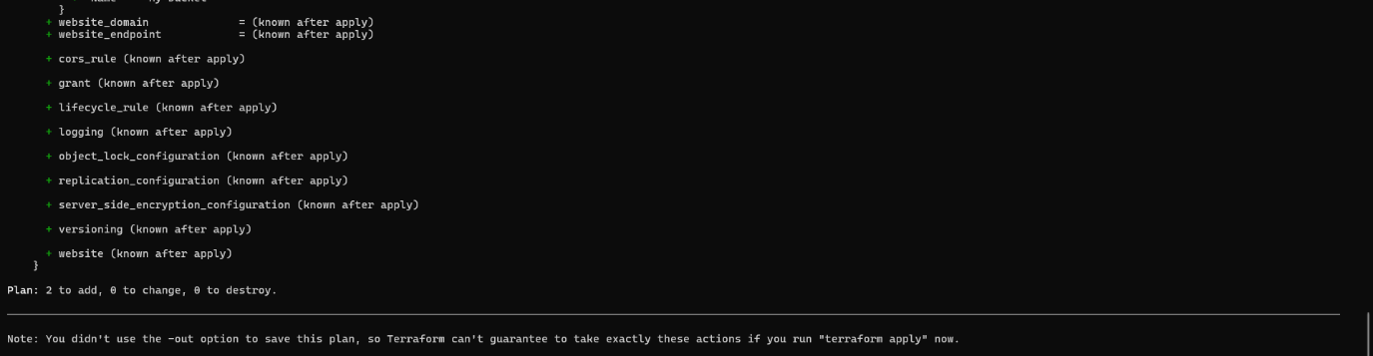

Step 6: Apply the Changes:
Create the resources:
terraform apply
When prompted, type yes to confirm.

Output:-

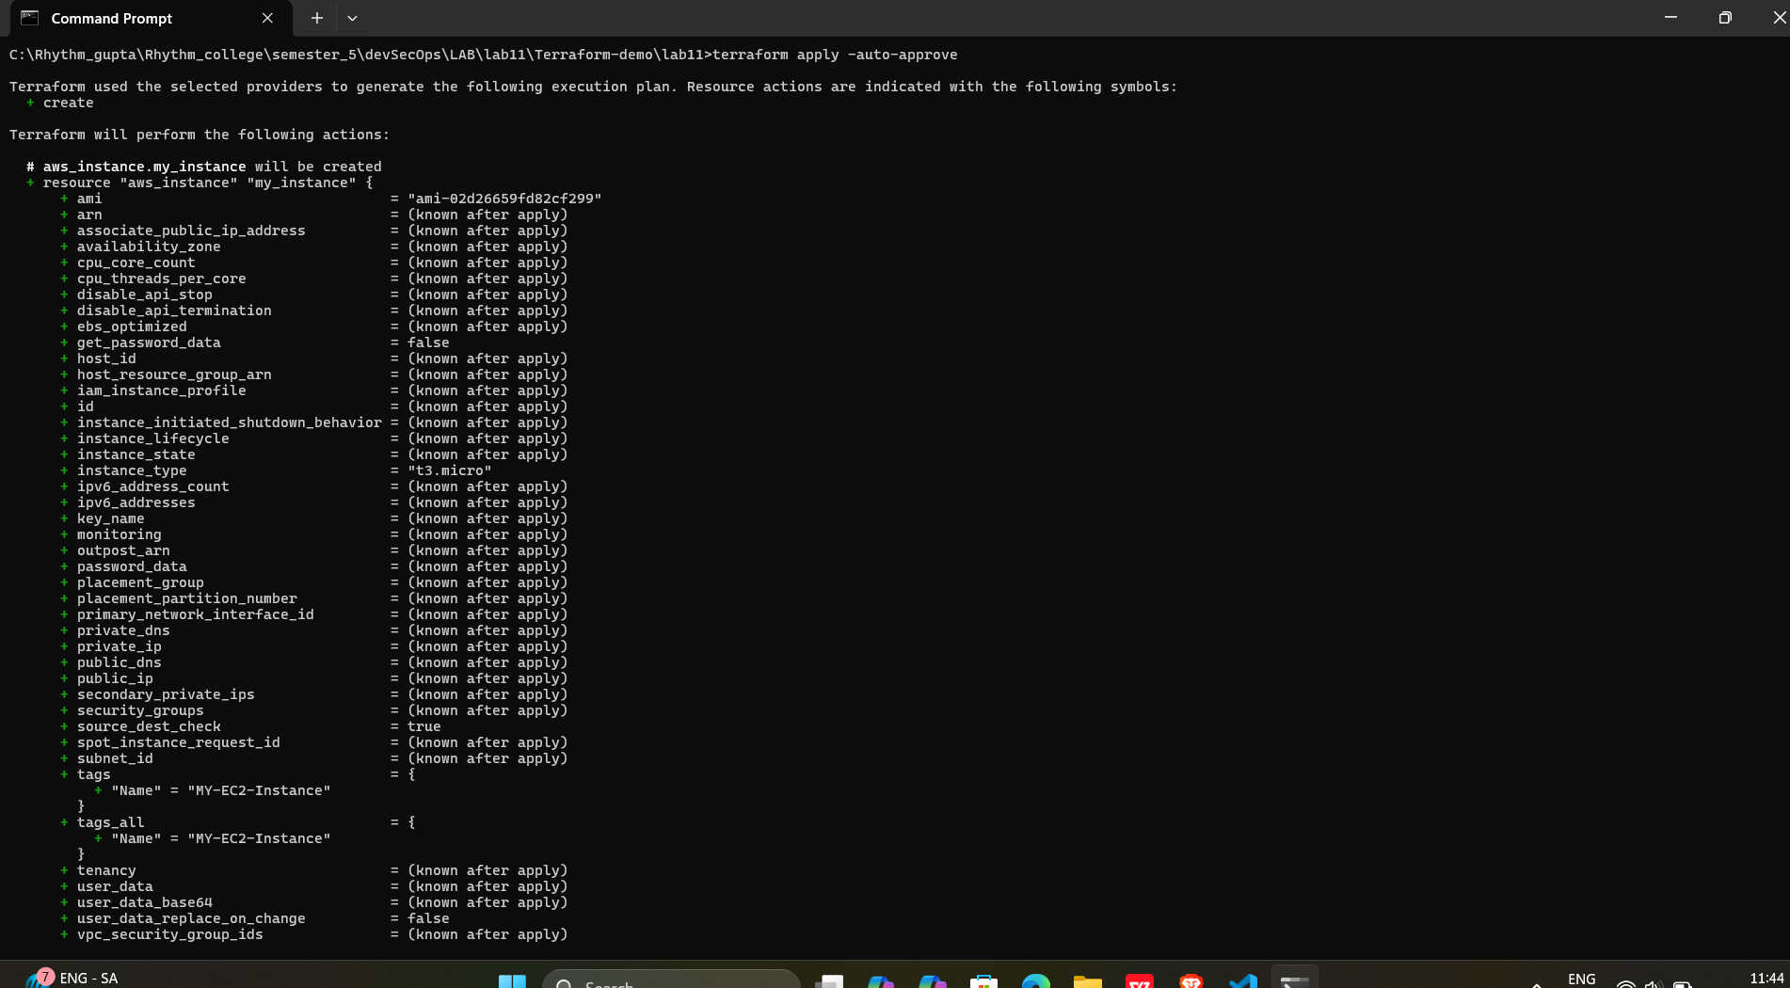
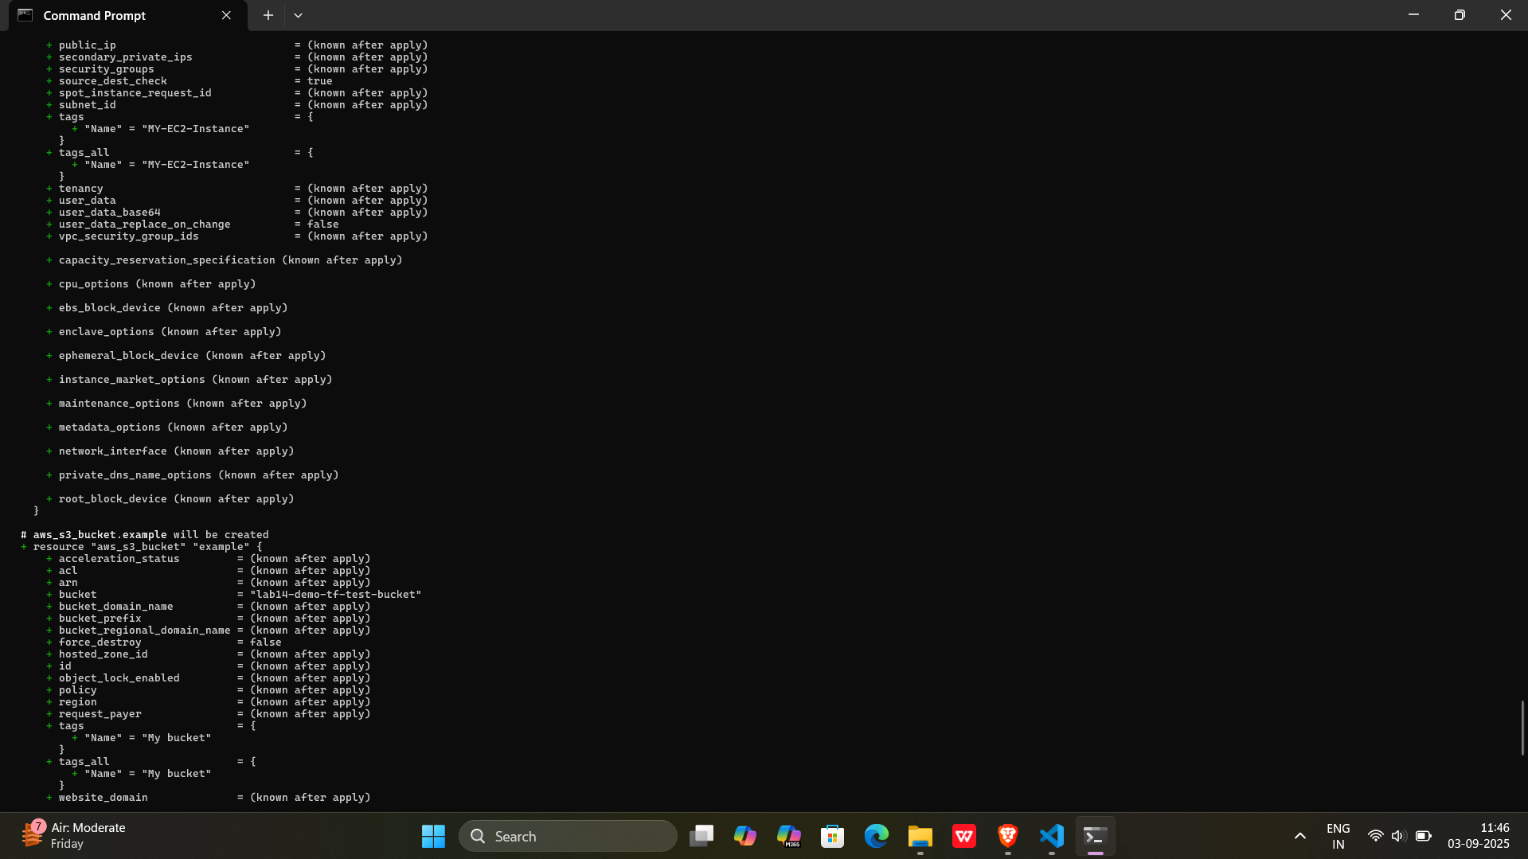
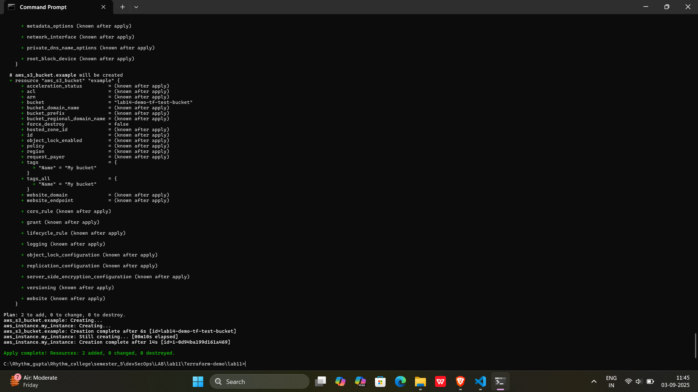

Step 7: Verify Resources:
- Log in to your AWS Management Console.
- Navigate to the S3 dashboard.
- Verify that the S3 bucket has been created with the specified configuration.

Output:-

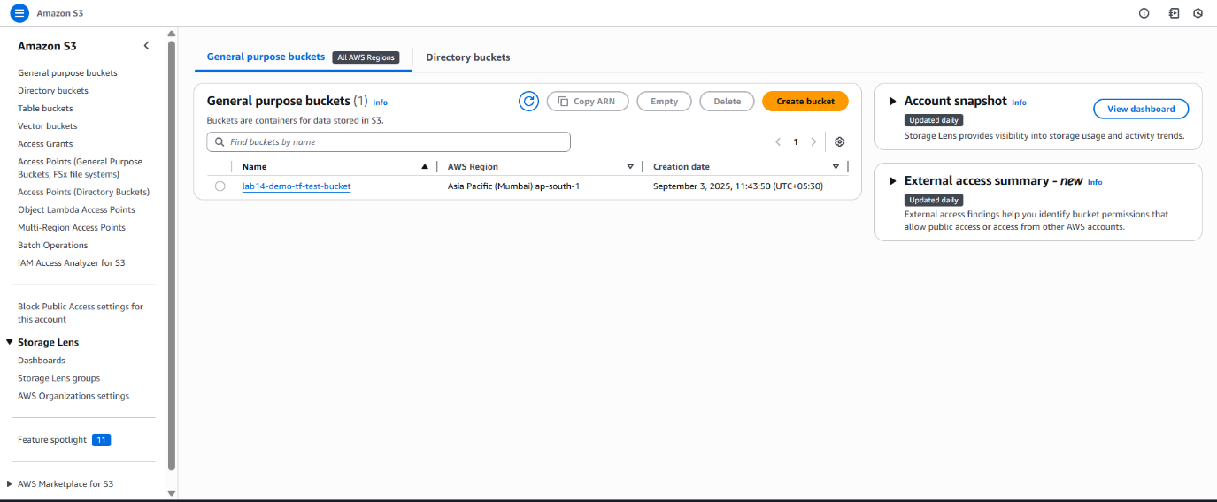

Step 8: Cleanup Resources:

To remove the resources created, run the following command:
terraform destroy
When prompted, type yes to confirm

Output:-

